Assembly Instructions

1. PickBot

1.1. Mounting the Aluminium
Start with base platform (Agilex Scout Mini).
Place the 300 mm aluminium extrusions at the front of the rails, perpendicular to the rail direction and central to the robot, as seen in figure 1.
Use M4 screws and t-nuts to fix the extrusions to the rails.
Mount the robot arm to the rails using M5 bolts and t-nuts. Placement should be central to the width of the scout mini, as seen in figure 1.
Use 90-degree aluminium mounting brackets to fix the 600 mm extrusion vertically on the left-hand side of the back piece of horizontal extrusion, as see in figure 2.
Mount the 450 mm aluminium extrusion behind the vertical pole, fixed to the pole and the horizontal extrusion for stability using M4 bolts and t-nuts, as seen in figure 3.
Mount the 345 mm aluminium extrusion at the top of the longer vertical pole, parallel to the length of the scout mini and perpendicular to the mounting pole using an m4 bolt and t-nut. The longer part of the extrusion will point to the back of the robot.
Mount the ‘camera_base’ 3D print such that is supports the horizonal extrusion, using m5 screws and t-nuts, as seen in figure 4.
Returning to the bottom 300 mm mounting rails, use 90-degree aluminium brackets to mount the 100 mm extrusion onto the front of the front-most extrusion, in the centre of the extrusion.

1.2. Mounting the Camera
Use the mount the ‘camera_mount_top’ 3D print on the front of the horizontal extrusion so the flat part is parallel to the front of the extrusion.
Connect the orbbec femto mega depth camera to the mount by using m2.5 bolts to fix the rear side mounting holes to the mount arms.
Use the ‘camera_mount_bottom’ 3D prints to connect the front side mounting holes of the camera to the extrusion using m2.5 bolts for the camera side and m5 bolts for the extrusion sides. Adjust the angle as desired and tighten.
Camera assembly is shown in figure 5.

1.3. Mounting the LiDAR
Remove the plastic divider and standoffs from the LiDAR module.
Use the standoffs to create 3 legs of equal length by connecting 2 standoffs together.
Use the provided screws to mount the legs to the ‘LiDAR_plate’ 3D print.
Mount the LiDAR plate to the 100 mm aluminium extrusion with the wide part forward and the legs upward.
Use the provided screws to mount the LiDAR module to the legs.
The LiDAR assembly is shown in figure 6.

1.4. Mounting the base plate
Place the ‘plate_with_holes_square_m6’ laser cut on the scout mini’s rails behind the aluminium extrusion with the indent forward and the rectangular cutout on the left hand side.
Use m5 bolts an t-nuts to fix the right-hand side to the rail.

1.5. Mounting the Jetson
The mounting holes for the Jetson will be on the front right of the mounting plate.
Cover the part of the mounting plate where the jetson will sit with electrical tape to prevent shorts.
Place the jetson on top of the electrical tape, with the ports facing to the outside of the robot.
Place the ‘jetson_mount’ 3D print over the top of the Jetson Orin Nano such that the gaps allow the ports to remain accessible.
Attach the mount to the plate with m6 screws and nuts.

1.6. Mounting the Power converter
Mount the power converter using m5 bolts behind the jetson.
The right-hand holes will be mounted through the plate into the rails so will require t-nuts. The left-hand holes will be mounted with regular m5 nuts.

1.7. Mounting the Battery
Place the Bluetti Elit 10 Battery on the large flat area of the plate between the jetson and the left-hand screws with the display facing the left-hand side of the robot.
Use a ratchet strap looped around the battery and under the plate to secure it.
The full mounting plate setup figure 7.

1.8. Mounting the GPS hardware
Place the gps module into the ‘gps_mount’ 3D print with the power port at the bottom.
Mount the module to the long vertical aluminium extrusion using an m5 bolt and t-nut.
Fix the antenna to the ‘antenna_tower’ 3D print using the included hardware and an m5 washer.
Fix the assembly to the back of the camera extrusion with m5 bolts and t-nuts to provide maximum distance from any electronics.
The antenna tower is shown in figure 8.

1.9. Power
Mount the power brick for the arm with a press fit into the remaining gap on the base plate.
Plug the input into the AC port of the Bluetti Elite 10.
Plug the output into the arm.
Use a 2.1 mm, 20 AWG, male-to-male barrel jack to connect the camera to the Bluetti Elite 10’s DC port.
Use chocolate block connector to connect the scout mini’s aviation adaptor to the input of the power converter.
Use chocolate block connector to connect the output of the power converter to a 2.5 mm, 18 AWG, make barrel jack.
Plug the barrel jack into the jetson.

1.10. Data
Use to USB to CAN adaptors the connect the arm CAN to the Jetson’s top-left USB, and the scout CAN beneath it.
Connect the LiDAR and GPS to the other USB ports using provided cables.
Connect the camera to the USB-C port.
Connect the GPS module to the antenna using the provided cable.

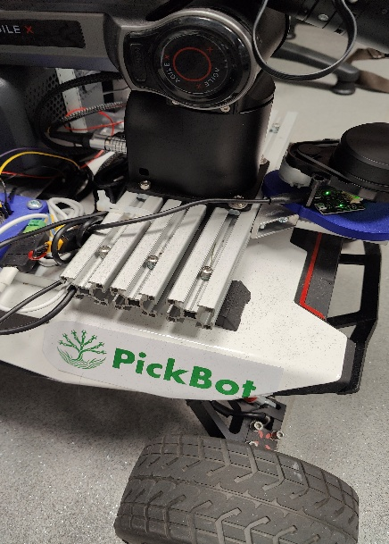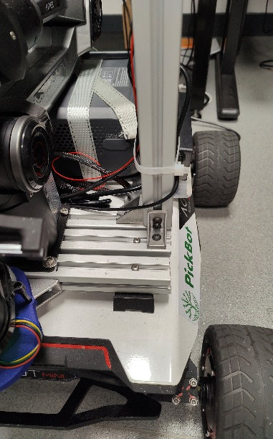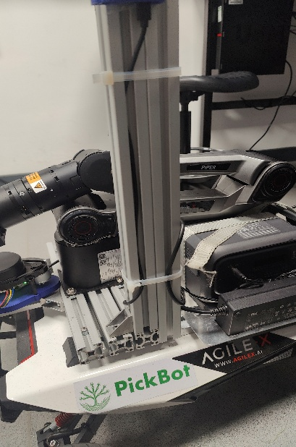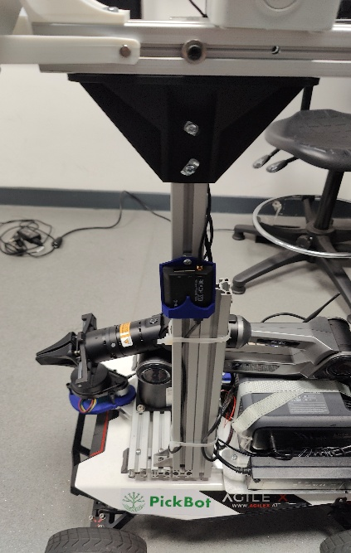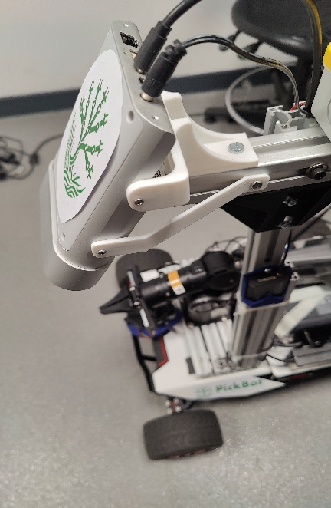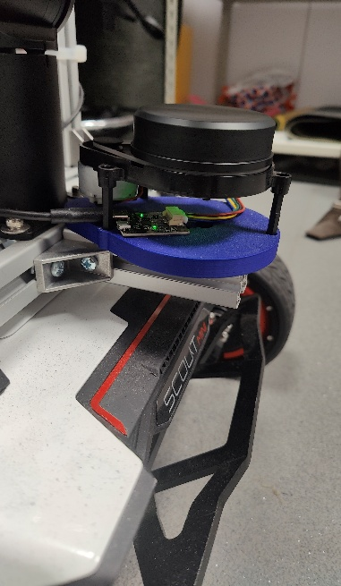
6
5
4
3
2
1
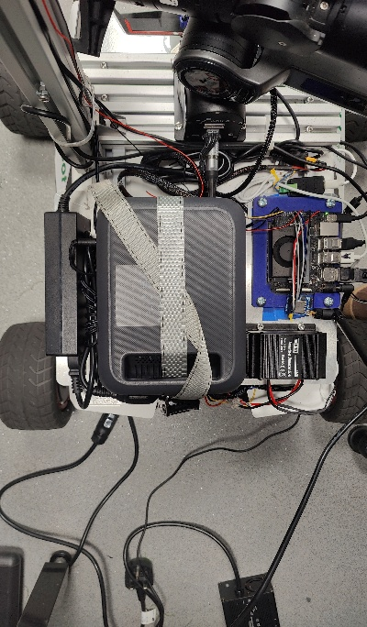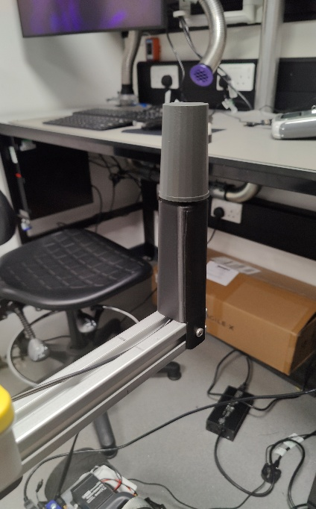
8
7

1.11 Buzzer, Emergency stop, Comms
Connect the buzzer, emergency stop and LoRa board to the GPIO pins on the Jetson in accordance with the wiring diagram.
Connect the LoRa antenna to the LoRa Board.

2. BinBot

2.1. Drilling the Box
Use the holes in the plate to lineup drilling holes at the front of the box in the centre of the bottom panel of the box and drill m5 clearance holes.
Place the box on the scout mini’s rails with the suitable clearance off the front for the LiDAR and mark 4 holes for mounting the box to the rails.
Drill m5 clearance holes at the marked positions.

2.2. Mounting the LiDAR
Fix the legs to the ‘LiDAR_plate’ 3D print as with the PickBot.
Mount the LiDAR plate to the underside of the box.
Fix the LiDAR to the mounting plate as with the PickBot.

2.3. Mounting the Box
Mount the box to the rails using m5 bolts and t-nuts so that the LiDAR is off the front of the robot.

2.4. Fixing the Mounting Plate
Place the ‘plate_with_holes_follow_m6’ on the scout mini’s rails.
Mount the converter on the right and use m5 bolts and t-nuts on the right-hand side to fix it to the rails. Use m5 bolts and nuts to fix the left-hand side of the converter to the plate.
Use a 90-degree aluminium bracket and to fix the left-hand side of the plate to the rails.
Fix the 200 mm aluminium extrusion vertically to the bracket.
The mounting plate setup is shown in figure 9.

2.5. Mounting the GPS hardware
Fix the gps hardware to the vertical extrusion in the same way as the PickBot.

2.6. Power
Power the Jetson in the same way as on the PickBot.

2.7. Data
Connect the scout mini CAN in the same way as the PickBot.
Connect the GPS and LiDAR to the Jetson via USB

2.8 Buzzer, Emergency stop, Comms
Connect the buzzer, emergency stop and LoRa board to the GPIO pins on the Jetson in accordance with the wiring diagram.
Connect the LoRa antenna to the LoRa Board.

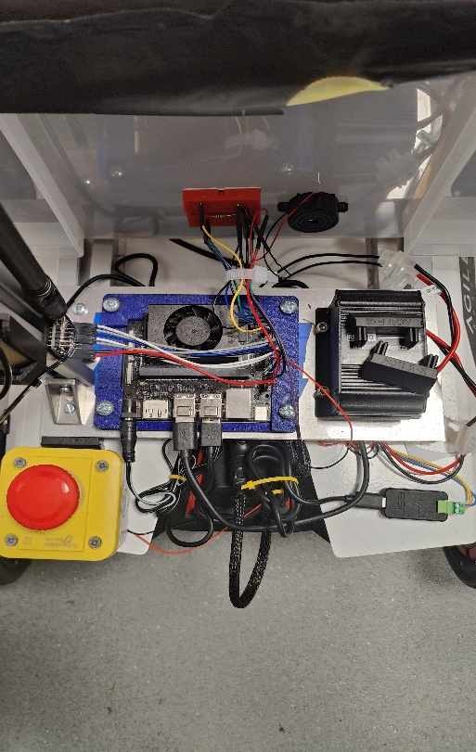
9

3. Parts

3.1. PickBot
3D Printed Parts
File Name | Quantity | Material
camera_mount_top | 1 | PLA
camera_mount_bottom_1 | 2 | PLA
Camera_base | 1 | PLA
antenna_tower | 1 | PLA
gps_mount | 1 | PLA
LiDAR_plate | 1 | PLA

Laser Cut Parts
File Name | Quantity | Material | Thickness
plate_with_holes_square_m6 | 1 | Aluminium | 2 mm

Aluminium Extrusion
Length | Profile | Holes | Hole Positions | Quantity
300 mm | 30 mm * 30 mm | 2 * m4 | 45 mm from each end | 3
600 mm | 30 mm * 30 mm | none |  | 1
450 mm | 30 mm * 30 mm | 2 * m4 | 15 mm from each nice | 1
350 mm | 30 mm * 30 mm | 1 * m4 | 100 mm from one end | 1
100 mm | 30 mm * 30 mm | none

3.2. BinBot
3D Printed Parts
File Name | Quantity | Material
antenna_tower | 1 | PLA
gps_mount | 1 | PLA
LiDAR_plate | 1 | PLA

Laser Cut Parts
File Name | Quantity | Material | Thickness
plate_with_holes_follow_m6 | 1 | Aluminium | 2 mm

Aluminium Extrusion
Length | Profile | Holes | Hole Positions | Quantity
200 mm | 30 mm * 30 mm | none |  | 1

3.3. Off-the-shelf Parts
Refer to bill of materials.

